Semester One Examination, 2020

Question/Answer booklet
MATHEMATICS

If required by your examination administrator, please
place your student identification label in this box

SPECIALIST UNIT 3
Section Two:

Calculator-assumed

WA student number: In figures

In words

Your name

Time allowed for this section Number of additional
Reading time before commencing work: ten minutes answer booklets used
Working time: one hundred (if applicable): minutes

Materials required/recommended for this section
To be provided by the supervisor
This Question/Answer booklet
Formula sheet (retained from Section One)

To be provided by the candidate
Standard items: pens (blue/black preferred), pencils (including coloured), sharpener, correction fluid/tape, eraser, ruler, highlighters

Special items: drawing instruments, templates, notes on two unfolded sheets of A4 paper, and up to three calculators approved for use in this examination

Important note to candidates
No other items may be taken into the examination room. It is your responsibility to ensure that you do not have any unauthorised material. If you have any unauthorised material with you, hand it to the supervisor before reading any further.

Structure of this paper

Section | Number of questions available | Number of questions to be answered | Working time  (minutes) | Marks available | Percentage  of  examination
Section One:  Calculator-free | 8 | 8 | 50 | 52 | 35
Section Two:  Calculator-assumed | 13 | 13 | 100 | 98 | 65
 |  |  |  | Total | 100

Instructions to candidates

- The rules for the conduct of examinations are detailed in the school handbook. Sitting this examination implies that you agree to abide by these rules.
DO NOT WRITE IN THIS AREA AS IT
WILL BE CUT OFF

- Write your answers in this Question/Answer booklet preferably using a blue/black pen. Do not use erasable or gel pens.

- You must be careful to confine your answers to the specific question asked and to follow any instructions that are specific to a particular question.

- Show all your working clearly. Your working should be in sufficient detail to allow your answers to be checked readily and for marks to be awarded for reasoning. Incorrect answers given without supporting reasoning cannot be allocated any marks. For any question or part question worth more than two marks, valid working or justification is required to receive full marks. If you repeat any question, ensure that you cancel the answer you do not wish to have marked.

- It is recommended that you do not use pencil, except in diagrams.

- Supplementary pages for planning/continuing your answers to questions are provided at the end of this Question/Answer booklet. If you use these pages to continue an answer, indicate at the original answer where the answer is continued, i.e. give the page number.

- The Formula sheet is not to be handed in with your Question/Answer booklet.
Section Two: Calculator-assumed 65% (98 Marks)
This section has thirteen questions. Answer all questions. Write your answers in the spaces provided.

Working time: 100 minutes.

Question 9  The function 𝑓(𝑧) is of degree 4 and has factors 𝑧 − 4 − 𝑖 and 𝑧 + 3𝑖. | (5 marks)
(a) Determine 𝑓(𝑧) in the form 𝑧⁴ + 𝑎𝑧³ + 𝑏𝑧² + 𝑐𝑧 + 𝑑, where {𝑎, 𝑏, 𝑐, 𝑑} ∈ ℝ. | (3 marks)

DO NOT WRITE IN THIS AREA AS IT WILL BE CUT OFF

(b) Explain whether your answer to part (a) would change if the coefficients of the polynomial
𝑓(𝑧) were not restricted to real numbers. (2 marks) Question 10 (8 marks)
The graph of 𝑦 = 𝑓(𝑥) is shown below over the domain −2 ≤ 𝑥 ≤ 6.

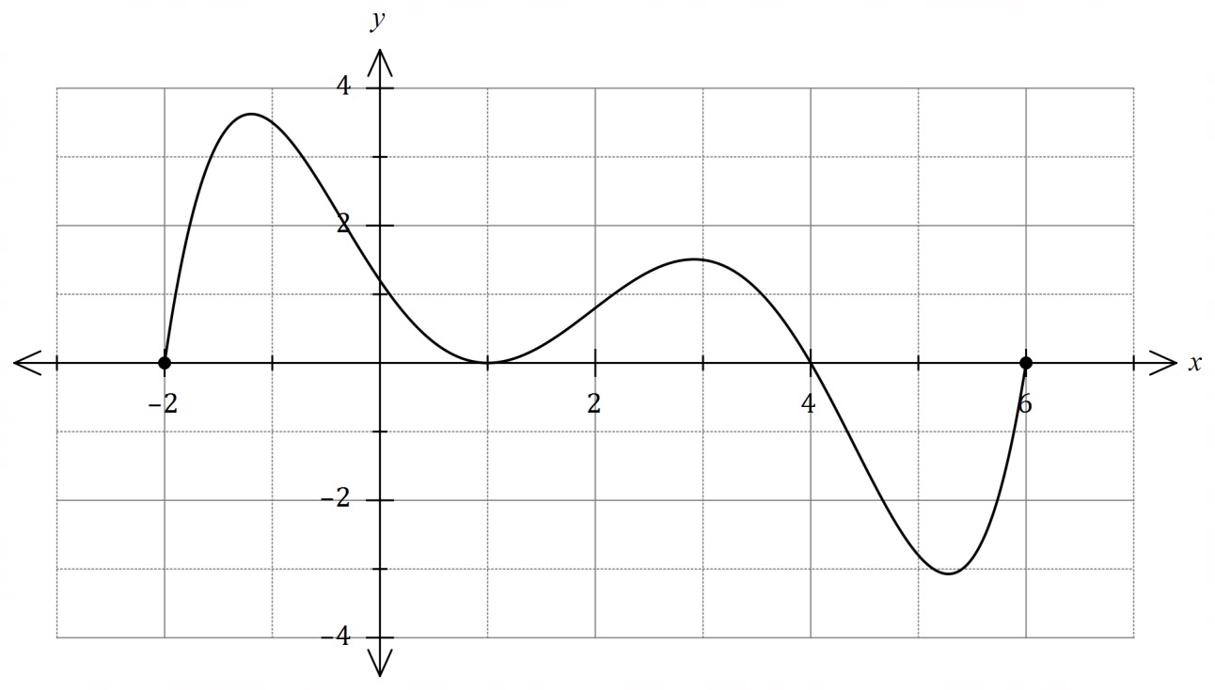

DO NOT WRITE IN THIS AREA AS IT
WILL BE CUT OFF

(a) Sketch the graph of 𝑦 = 𝑓(|𝑥|) over the domain −3 ≤ 𝑥 ≤ 3 on the axes below. (2 marks)

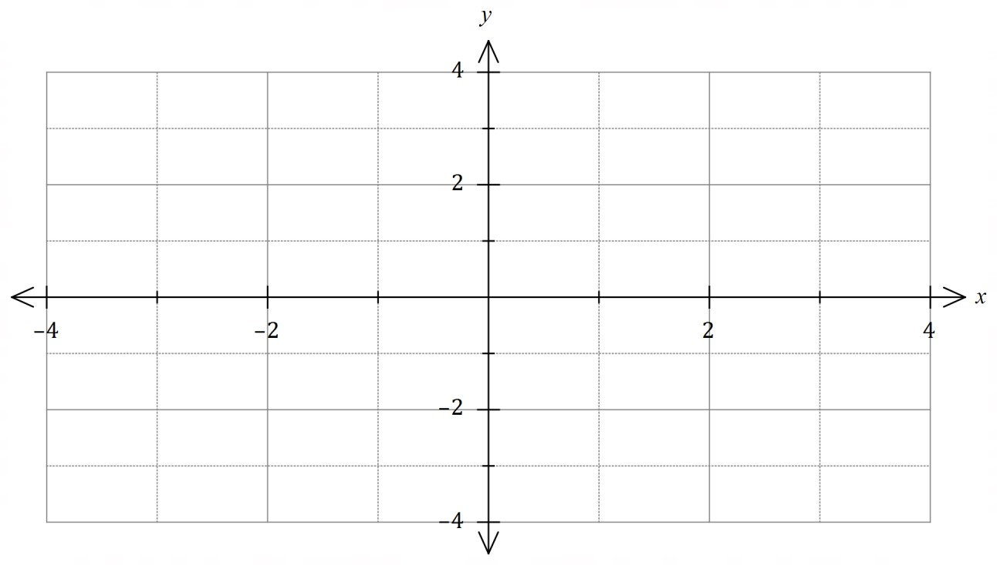

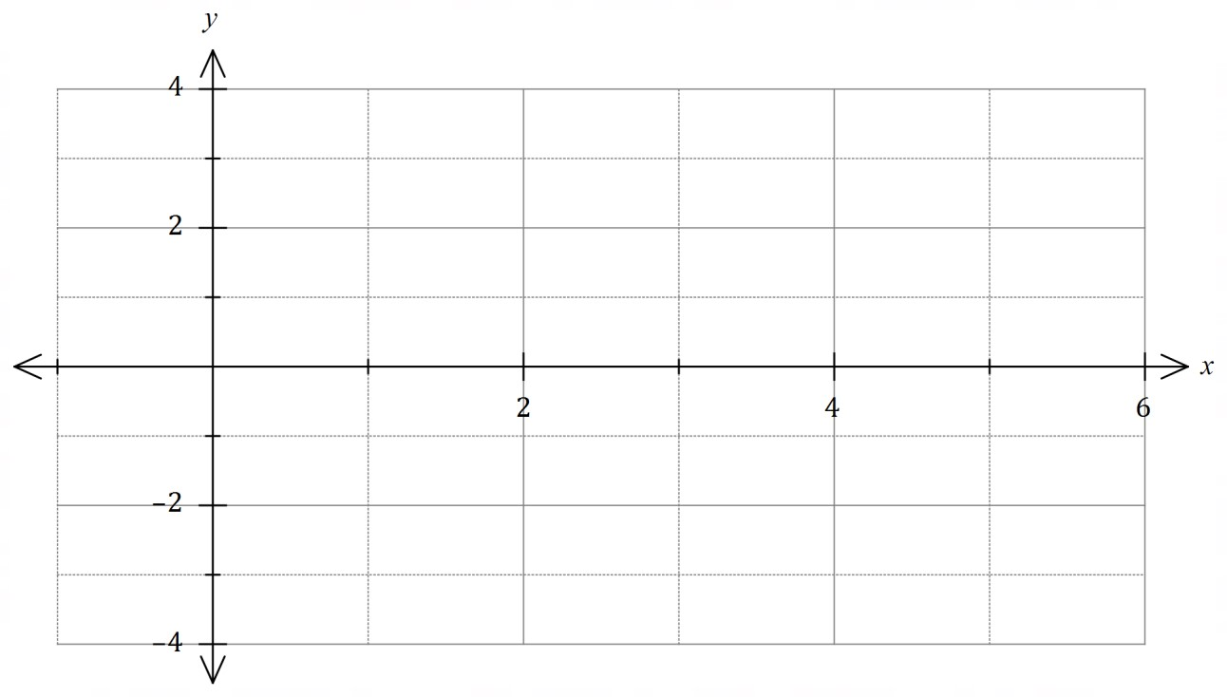
(
b
)

Sketch the graph of
𝑦
=
1
𝑓
(
𝑥
)

on the axes below over the domain
0
≤
𝑥
≤
5
.

(4
marks
)

DO NOT WRITE IN THIS AREA AS IT WILL BE CUT OFF

1
(c) List the equations of all asymptotes of the graph of 𝑦 = when drawn over the
𝑓(|𝑥|)
domain −6 ≤ 𝑥 ≤ 6. (2 marks) Question 11 (8 marks)
Drone 𝐴 and drone 𝐵 move with constant velocities and relative to the origin 𝑂 have initial positions (−4, 22,2) and (5, 15,3) respectively, where distances are in metres.

One second later, the position of 𝐴 is (−1, 20,3) and the position of 𝐵 is (1, 14,8).

- Determine a position vector relative to the origin for each drone after 𝑡 seconds. (3 marks)

DO NOT WRITE IN THIS AREA AS IT
WILL BE CUT OFF

- Determine an expression for the distance between the two drones at any time 𝑡, 𝑡 ≥ 0.
(3 marks)

- Determine the minimum distance between the drones. (2 marks) Question 12 (7 marks)
The graph of 𝑓(𝑥) = |𝑎𝑥 + 𝑏| + 𝑐 is shown below.

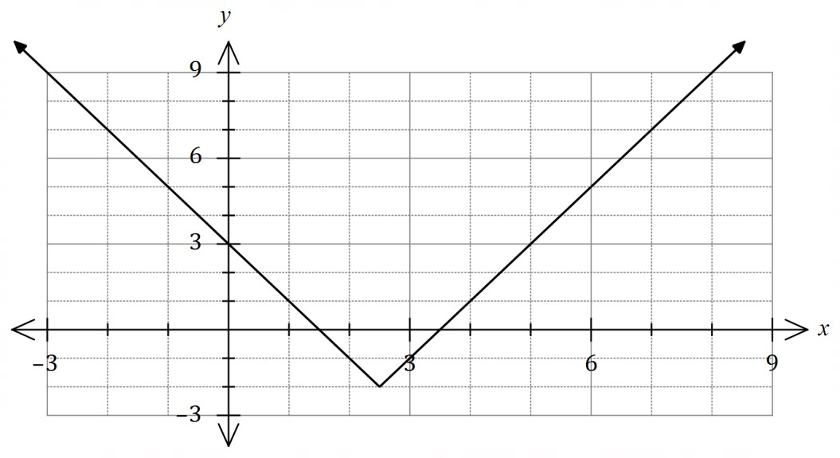

- Determine all possible values of the constants 𝑎, 𝑏 and 𝑐. (3 marks)

DO NOT WRITE IN THIS AREA AS IT WILL BE CUT OFF

- Using the graph, or otherwise, solve

  - 𝑓(𝑥) = 5. (1 mark)

  - 𝑓(𝑥) = 𝑥. (1 mark)

  - 𝑓(𝑥) + 2𝑥 = 3. (2 marks) Question 13 (9 marks)
15𝑡 15𝑡²
The path of a particle with position vector 𝐫(𝑡) = 𝐢 + 𝐣 metres is shown below, where 𝑡
1 + 𝑡³ 1 + 𝑡³
is the time in seconds and 𝑡 ≥ 0.

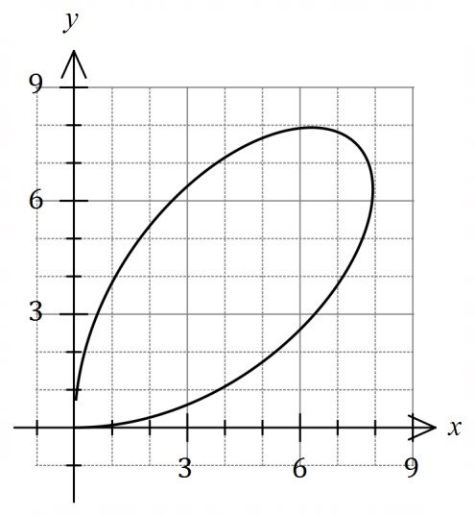
DO NOT WRITE IN THIS AREA AS IT
WILL BE CUT OFF

- Determine the initial velocity of the particle. (2 marks)

- Determine the velocity of the particle at the instant, 𝑡 > 0, when it is moving parallel to the
𝑥-axis. (2 marks)

- Explain whether the particle will return to its initial position. (2 marks)

DO NOT WRITE IN THIS AREA AS IT WILL BE CUT OFF

- Observing that 𝑦 − 𝑥𝑡 = 0, show that the Cartesian equation for the path of the particle can be expressed in the form 𝑥³ + 𝑦³ = 𝑘𝑥𝑦 and state the value of the constant 𝑘.
(3 marks)

Question 14  Let 𝑓(𝑥) = | ^{𝑥 + 2} |.  𝑥 − 1 | (7 marks)
(a) Sketch the graph of 𝑦 = 𝑓(𝑥) on the axes below. | (3 marks)
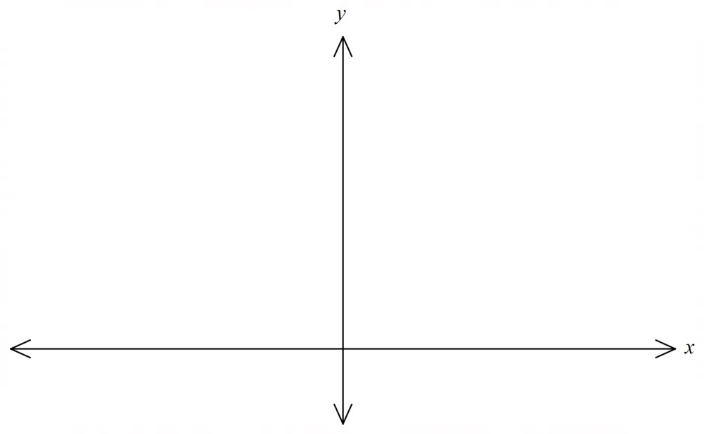
(b) State the range of 𝑓(𝑥). | (1 mark)

DO NOT WRITE IN THIS AREA AS IT
WILL BE CUT OFF

(c) The domain of 𝑓 is restricted to −2 ≤ 𝑥 < 𝑏 so that 𝑓⁻¹ is a function. State the value of the constant 𝑏 so that the domain of 𝑓 is as large as possible and determine the domain and
range for 𝑓⁻¹. (3 marks)

Question 15  The complex numbers 𝑧, 𝑧𝑤 and 𝑧𝑤² are represented on the Argand diagram below. | (8 marks)
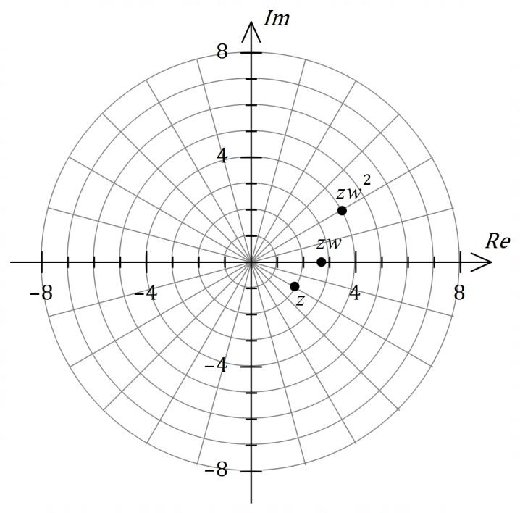
- Express 𝑧 exactly in the form 𝑎 + 𝑏𝑖. (2 marks)

- Determine the modulus and argument of 𝑧𝑤⁵. (4 marks)

DO NOT WRITE IN THIS AREA AS IT WILL BE CUT OFF

- Determine 𝑧𝑤⁻² and plot and label this point on the Argand diagram. (2 marks) Question 16 (9 marks)
(a) Let 𝑓(𝑥) = 𝑥2 − 4𝑥 − 2 .

𝑥 − 1

(i) Briefly describe the feature of the rule for 𝑓(𝑥) that indicates the graph of 𝑦 = 𝑓(𝑥)
DO NOT WRITE IN THIS AREA AS IT
WILL BE CUT OFF

 | will have an oblique (slanted) asymptote. | (1 mark)
(ii) | Determine the equations of all asymptotes of the graph of 𝑦 = 𝑓(𝑥). | (3 marks)

(𝑥 − 2)(𝑥 + 3) 𝑥² + 1
(b) Let 𝑔(𝑥) = .

- State the equation of the horizontal asymptote of the graph of 𝑦 = 𝑔(𝑥). (1 mark)

- State the values of 𝑔(6), 𝑔(7) and 𝑔(8). (1 mark)
DO NOT WRITE IN THIS AREA AS IT WILL BE CUT OFF

- Use your previous two answers to explain why the graph of 𝑦 = 𝑔(𝑥) must have a
local maximum to the right of 𝑥 = 7. (3 marks)

Question 17 (8 marks)
3 2 1
Plane Π has equation 𝐫 = (−2) + 𝜇 ( 1 ) + 𝜆 (−1).

4 −1 2

- Show how to deduce that the Cartesian equation of plane Π is 𝑥 − 5𝑦 − 3𝑧 = 1.
(3 marks)

DO NOT WRITE IN THIS AREA AS IT
WILL BE CUT OFF

The line through 𝐴(1, 4, 5) and point 𝐵 is perpendicular to Π, and the midpoint of 𝐴𝐵 lies in Π.

- Determine the coordinates of 𝐵. (5 marks)

Question 18 (8 marks)
- Determine, in the form 𝑟 cis 𝜃, the solution of the equation 𝑧⁴ + 625𝑖 = 0 that lies in the
third quadrant of the complex plane (−𝜋 < 𝜃 < − ^{𝜋} ). (4 marks)
2

DO NOT WRITE IN THIS AREA AS IT WILL BE CUT OFF

- Writing 5 − 12𝑖 = (𝑎 + 𝑏𝑖)², {𝑎, 𝑏} ∈ ℝ, or otherwise, use an algebraic method that does
not involve CAS to determine the square roots of 5 − 12𝑖. (4 marks) Question 19 (9 marks)
The position vectors of particles 𝐴 and 𝐵 (in centimetres) at time 𝑡 seconds, 𝑡 ≥ 0, are

𝐫_{𝐴} = 7𝐢 + 15𝐣 + 𝑡(0.5𝐢 − 2𝐣) and 𝐫_{𝐵} = 5𝐢 + 2𝐣 + 𝑡((𝑡 − 6)𝐢 − 𝐣).

- Show that 𝐴 is moving with constant speed and determine this speed. (2 marks)

- Determine the Cartesian path of 𝐵. (3 marks)
DO NOT WRITE IN THIS AREA AS IT
WILL BE CUT OFF

- Determine the position vector of the point where the paths of the particles cross.
(4 marks) Question 20 (8 marks)
- Shade the region in the complex plane below that simultaneously satisfies |𝑧 − 2𝑖| ≤ 3
DO NOT WRITE IN THIS AREA AS IT WILL BE CUT OFF

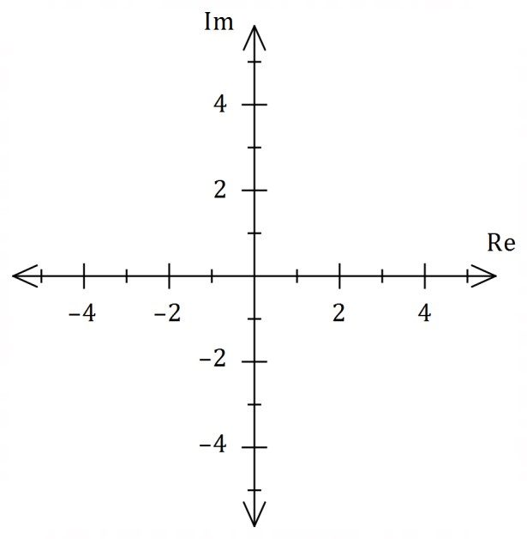
and
−
𝜋
2
≤
arg
(
𝑧
−
1
)
≤
𝜋
2
.

(4
marks
)

- The locus of |𝑧 + 2𝑖| = |𝑧 + 𝑎 + 𝑏𝑖| in the complex plane is the straight line shown below, {𝑎, 𝑏} ∈ ℝ.
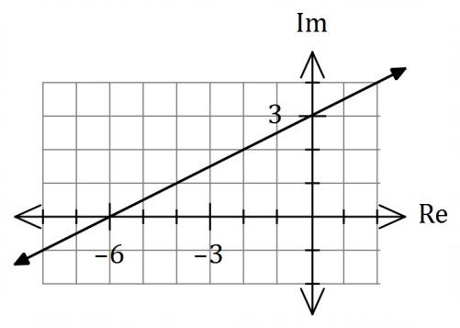
(i) State the value of constant 𝑎 and the value of constant 𝑏. | (2 marks)
(ii) Determine the minimum value of |𝑧| in exact form. | (2 marks)

Question 21 (4 marks)
Sphere 𝑆 of radius 3 has its centre at the origin.

−𝑘 1
Line 𝐿 has equation 𝐫 = ( 𝑘 ) + 𝜆 ( 2 ), where 𝑘 is a positive constant.

−𝑘 −2

Prove that for 𝐿 to be a tangent to 𝑆, then 𝑘 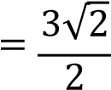.
DO
NOT WRITE IN THIS AREA AS IT WILL BE CUT OFF

End of questions
Supplementary page
DO NOT WRITE IN THIS
AREA AS IT WILL BE CUT OFF

Question number: _________

© 2020 WA Exam Papers. Seton Catholic College has a non-exclusive licence to copy and communicate this document for non-commercial, educational use within the school.
No other copying, communication or use is permitted without the express written permission of WA Exam Papers. SN128-154-2.

